|  |
| --- |
| NSS MITSOM-2.jpg |

**A Project Report**

**On**

**“INSURANCE MANAGEMENT SYSTEM"**

**Submitted in Partial Fulfillment of**

**Bachelor of Computer Applications (Semester VI)**

**UNIVERSITY OF PUNE**

**Submitted**

**By**

**KSHITIZ GOVIND THAKUR**

**Roll No: 119**

**Seat No:34539**

**ACKNOWLEDGEMENT**

I am very glad to take this opportunity to acknowledge all those who helped me in designing, developing and successful execution of my Project on “INSURANCE MANAGEMENT SYSTEM”.

I would like to extend my thanks and gratitude to my Project guide Prof Vrushali for her valuable guidance and timely assistance throughout the development of this project.

I would also like to extend my thanks and gratitude to my Course Incharge Prof. Vinaya Nimbolkar and Class Incharge Prof. Kalyani Belsare without whose help and support this project would not have been possible.

Thank you

|  |  |
| --- | --- |
| **Serial number** | **Topic** |
| 1 | **Introduction**  1.1 Introduction to system  1.2 Scope of System  1.3 Proposed System |
| 2 | **Analysis**  2.1 Fact Finding Techniques  2.1.1 Interview  2.1.2 Record View  2.1.3 Observation  2.2 Feasibility Study  2.3 Hardware and Software Requirements |
| 3 | **System Designing**  3.1 E-R Daigram  3.2 Context Level Daigram  3.3 Data Flow Daigram  3.4 File Dessign or Data Dictionary |
| 4 | **Form Designing(with input values)** |
| 5 | **Advantages and Limitation** |
| 6 | **Bibliography** |

**PAGE INDEX**

**1.1**

**INTRODUCTION TO SYSTEM**

Stream allocation involves different Processes Like Student Registration, College Registration, Aptitude test, giving suggestion to Students and Creating various Reports and several other tasks.

Performing all these tasks manually becomes too complex and time consuming.

The aim of this document is to gather and analyze and give an in-depth insight of the complete INSURANCE MANAGEMENT SYSTEM . This system will help to automate the work and make it easier for the schools and colleges to allocate students their preferred stream.

The process of stream allocation in a college will be done using the students Marks in 10th standard and the marks that he score in the aptitude test of the system.

The aptitude tests primary purpose is to better suggest colleges to the student which is best suited for him/her on the basis of his preference

**1.2**

**SCOPE OF THE SYSTEM**

The system will be a Stand Alone System for INSURANCE MANAGEMENT.

|  |  |
| --- | --- |
| The Insurance management system is a complete solution for organizations, which need to manage insurance for their vehicles, equipment, buildings, and other resources. Organizes and tracks insurance vendors and the policies provided under different coverage. | |
| We are offering a robust  [web based insurance solution](http://rndinfo.com/health-care-insurance-system.html), which has the flexibility of customizations to match the specific needs of clients for achieving their business goal of good service and revenue generation.  Insurance policy administration system consists of a mathematical notation that captures the relationship between policies and objects and the entities that manage policies for those objects.  Hence there is need for an automated system, which can efficiently manage the company, records, provides instant access and one that improves the productivity. As a result of this automated system, the activities of the company are performed with in the stipulated time and the reliable and efficient service is ensured to its users. |

**1**

**PROPOSED SYSTEM**

The proposed system provides user friendly interface and also provides powerful and efficient database management system. The aim of proposed system is to develop a system of improved facilities. The existing process of stream allocation in schools and colleges is done manually thus hampering its accuracy and effectiveness. The proposed system can overcome the limitations of the existing system.

The system provides proper security and reduces the manual work. The existing process of stream allocation has several disadvantages and many more difficulties to work. The proposed system tries to eliminate or reduce these difficulties up to some extent.

The proposed system will help the user to reduce the workload and mental conflict. Through this system it is possible to print various reports for the organization.

The aim of the proposed system is to develop a system of improved facilities.

* Security of data.
* Ensure data accuracy.
* Proposed control of the Higher Authority.
* Minimum time needed for the various processing.
* Greater efficiency.
* Better services.
* User friendliness and interactive.
* Minimum time required.

**2.1**

**FACT FINDING TECHNIQUES**

To study any system the analyst needs to collect facts and all relevant information. The facts when expressed in quantitative form are termed as data.

The success of any project depends upon the accuracy of available data. Accurate information can be collected with help of certain methods/ techniques. These specific methods for finding information of the system are termed as fact finding techniques.

Interview, Questionnaire, Record Review and Observations are the different fact finding techniques used by the analyst. The analyst may use more than one technique for investigation.

To make the system effective, I have followed following fact finding techniques to collect the detailed information about each and every aspect of MITSOM College depending upon the nature of work and information needed.

**2.1.1 Interview** : The Admission officer and College Representative who are the Key Persons of all College’s admission procedure were Interviewed to understand the system more openly.

**2.1.2 Record :** Observation of records of students and their expectations from their colleges and the requirement of colleges from their students were made.

**2.1.3 Observation :** This technique helped in understanding the actual process of INSURANCE MANAGEMENT SYSTEM, Student registration, Aptitude Test, Report Generation, etc

**2.2**

**FEASIBILITY STUDY**

The feasibility study is major factor, which contributes to the analysis and development of the system. The decision of the system analyst whether to design a particular system or not depends on its feasibility study.

1. **Operational Feasibility:-**

* The introduction to this system is not going to hamper any user of the system. This system is useful for administrator of any college office or school office.
* This system is very flexible and user friendly,
* This system provides GUI application.

1. **Technical Feasibility:-**

* This feasibility deals with technicality of the system. Instead of storing data of students in manual way this system is fully automated.
* No efficient manpower is required to handle the system.

1. **Economical Feasibility:-**

* This area is concerned with cost incurred for the development and implementation of the system .The maintenance of the system on the other hand and the benefits derived from it .The cost benefit analysis is effectiveness of the system.
* The benefits and savings obtained using the system is far more compared to the invested cost as it reduces operational costs through lower bills.

**4. Behavioural Feasibility:-**

This includes the following questions:

* Is there sufficient support for the users?
* Will the proposed system cause harm?

The project would be beneficial because it satisfies the objectives when developed and installed. All behavioral aspects are considered carefully and conclude that the project is behaviorally feasible.

**2.3**

**HARDWARE AND SOFTWARE REQUIREMENTS**

* **Hardware Specification**

Processor : Intel Dual based System

Processor Speed : 1GHz to 2GHz

RAM : 512MB to 1GB

Hard Disk : 4GB to 30GB

Keyboard : 104 keys

* **Software Specification.**

Language : Microsoft Visual Studio 2008(VB.NET)

Database : Microsoft Access 2003/7/10

Operating System : Windows NT / XP / Vista / 7/8/8.1

* **Network Specification.**

This software work stand alone system as well as network based system.

**ENTITY RELATIONSHIP DIAGRAM**

**CONTEXT LEVEL DIAGRAM**

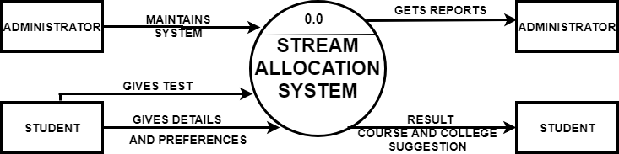

**DATA FLOW DIAGRAM**

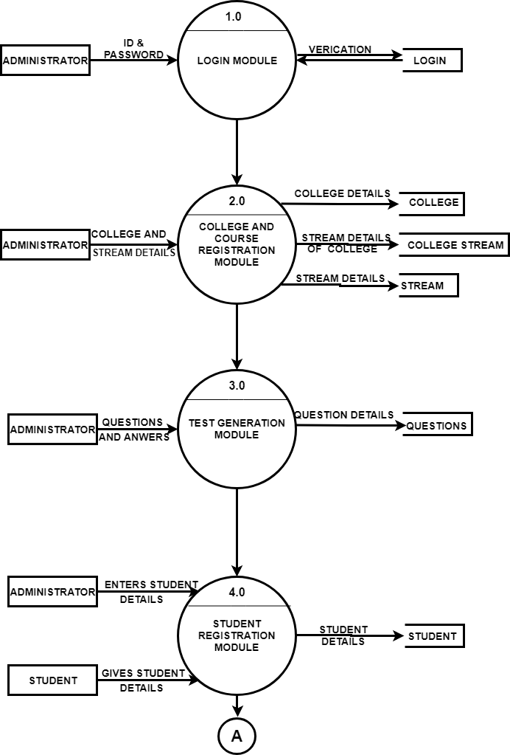

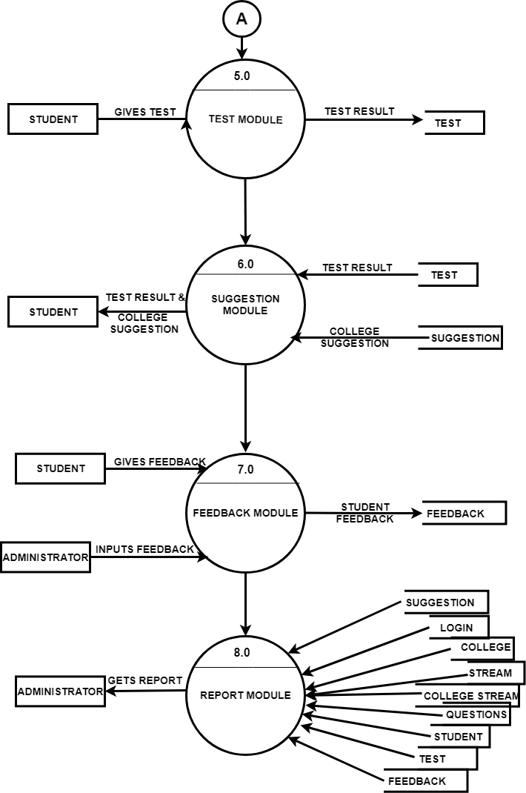

**DATA DICTIONARY**

**TABLE : STUDENTS**

|  |  |
| --- | --- |
| **ATTRIBUTES** | **DATA TYPE** |
| S_ID | AUTO NUMBER |
| S_NAME | TEXT |
| S_CONTACT | TEXT |
| S_EMAIL | TEXT |
| S_DOB | DATE/TIME |
| S_ADDRESS | TEXT |
| S_MARKS | TEXT |
| S_PREFERENCE | TEXT |

**TABLE : FEEDBACK**

|  |  |
| --- | --- |
| **ATTRIBUTES** | **DATA TYPE** |
| F_ID | AUTO NUMBER |
| F_DATE | DATE/TIME |
| S_NAME | TEXT |
| S_CONTACT | TEXT |
| R1 | TEXT |
| R2 | TEXT |
| R3 | TEXT |
| F_SUGGESTION | TEXT |

**TABLE : COLLEGE_STREAM**

|  |  |
| --- | --- |
| **ATTRIBUTES** | **DATA TYPE** |
| CS_ID | AUTO NUMBER |
| CL_ID | NUMBER |
| CL_NAME | TEXT |
| ST_ID | NUMBER |
| ST_NAME | TEXT |
| ST_REQUIREMENT | NUMBER |
| ST_FEES | NUMBER |

**TABLE : COLLEGE**

|  |  |
| --- | --- |
| **ATTRIBUTES** | **DATA TYPE** |
| CL_ID | AUTO NUMBER |
| CL_NAME | DATE/TIME |
| CL_ADDR | TEXT |
| CL_RANK | NUMBER |
| CL_CITY | TEXT |
| CL_CONTACT | TEXT |
| CL_EMAIL | TEXT |

**TABLE : QUESTION**

|  |  |
| --- | --- |
| **ATTRIBUTES** | **DATA TYPE** |
| Q_ID | AUTO NUMBER |
| SUBJECT | TEXT |
| QUESTION | TEXT |
| O1 | TEXT |
| O2 | TEXT |
| O3 | TEXT |
| O4 | TEXT |
| CA | TEXT |

**TABLE : NOTICES**

|  |  |
| --- | --- |
| **ATTRIBUTES** | **DATA TYPE** |
| ST_ID | AUTO NUMBER |
| ST_NAME | TEXT |
| ST_SUBTYPE | TEXT |
| ST_REQ | NUMBER |
| ST_MIN_TMARK | NUMBER |
| ST_DESC | TEXT |

**TABLE : SUGGESTIONS**

|  |  |
| --- | --- |
| **ATTRIBUTES** | **DATA TYPE** |
| SR_NO_ID | AUTO NUMBER |
| S_ID | NUMBER |
| S_NAME | TEXT |
| S_CONTACT | TEXT |
| ST_ID | NUMBER |
| ST_NAME | TEXT |
| ST_SUBTYPE | TEXT |
| CL_NAME1 | TEXT |
| CL_NAME2 | TEXT |
| CL_NAME3 | TEXT |

**TABLE : TEST**

|  |  |
| --- | --- |
| **ATTRIBUTES** | **DATA TYPE** |
| T_ID | AUTO NUMBER |
| T_DATE | DATE/TIME |
| T_SUBJECT | TEXT |
| S_ID | NUMBER |
| S_NAME | TEXT |
| T_MAKRS | NUMBER |

**LOGIN FORM**

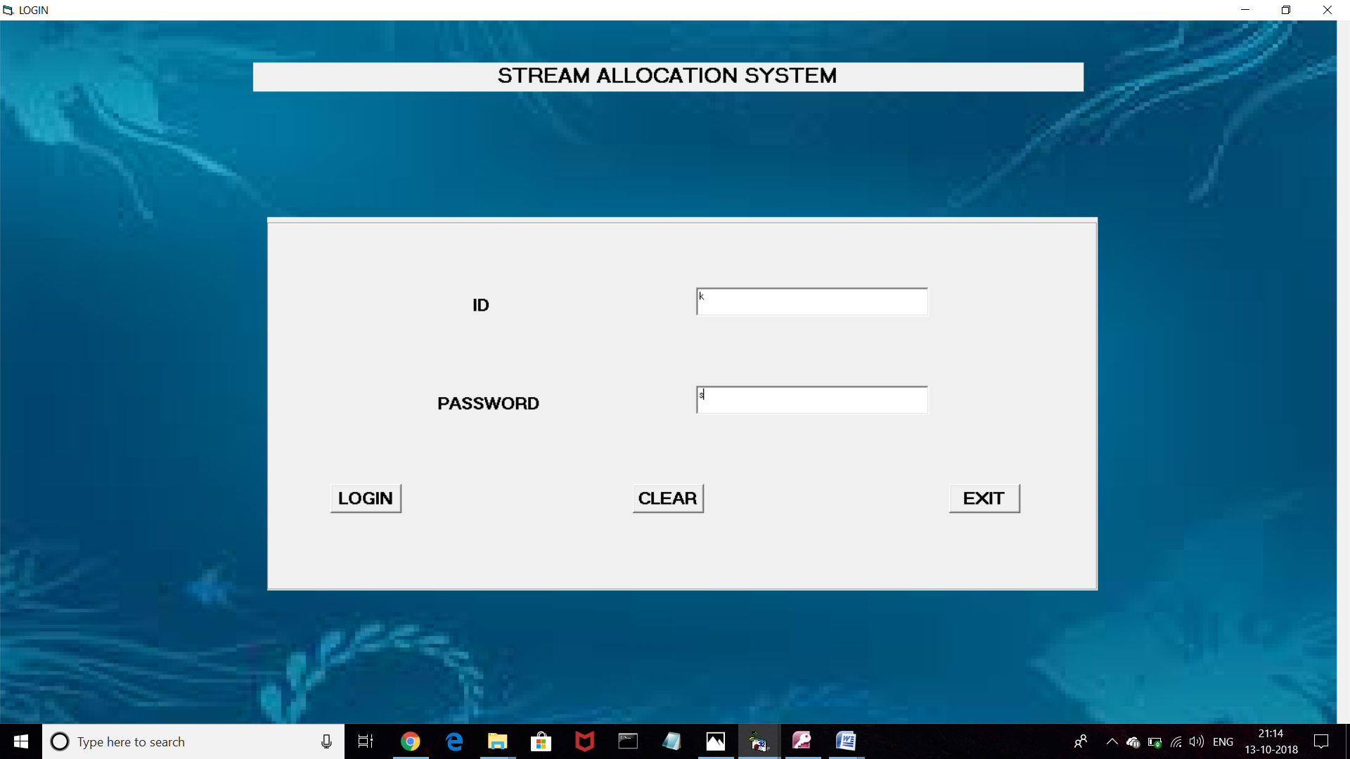

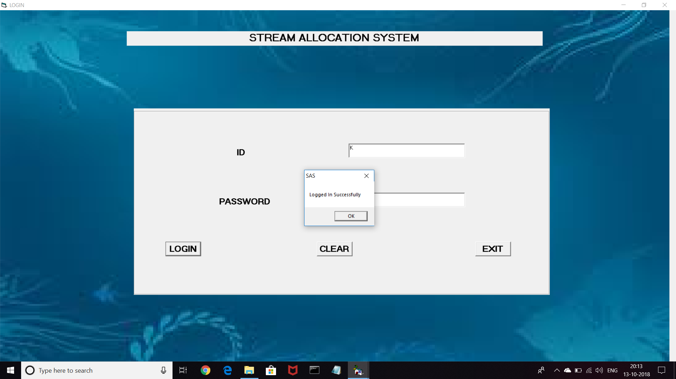

**MAIN MDI FORM**



**STUDENT REGISTRATION FORM**

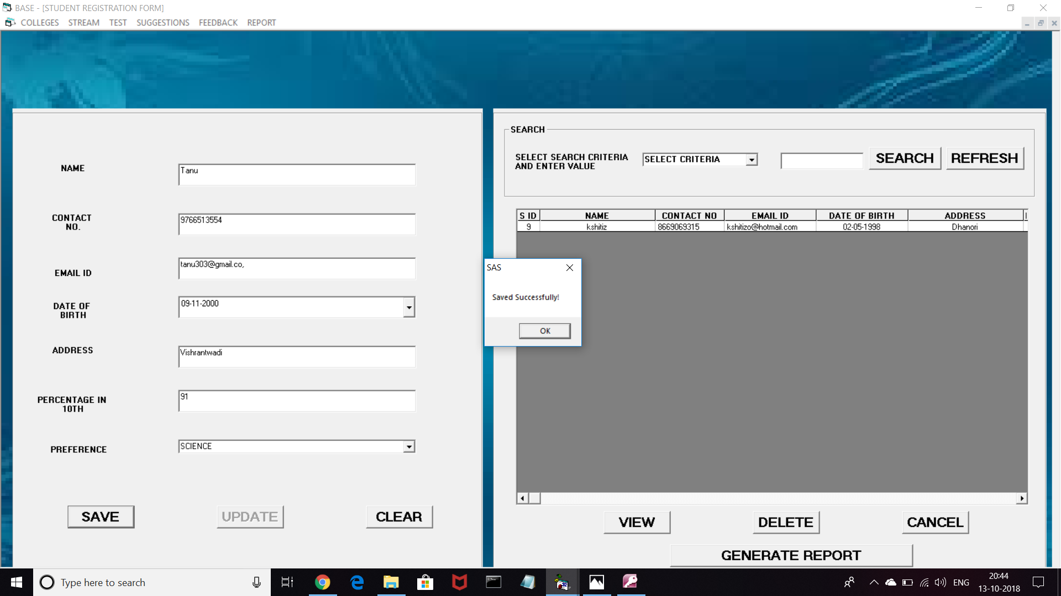

**COLLEGE REGISTRATION FORM**

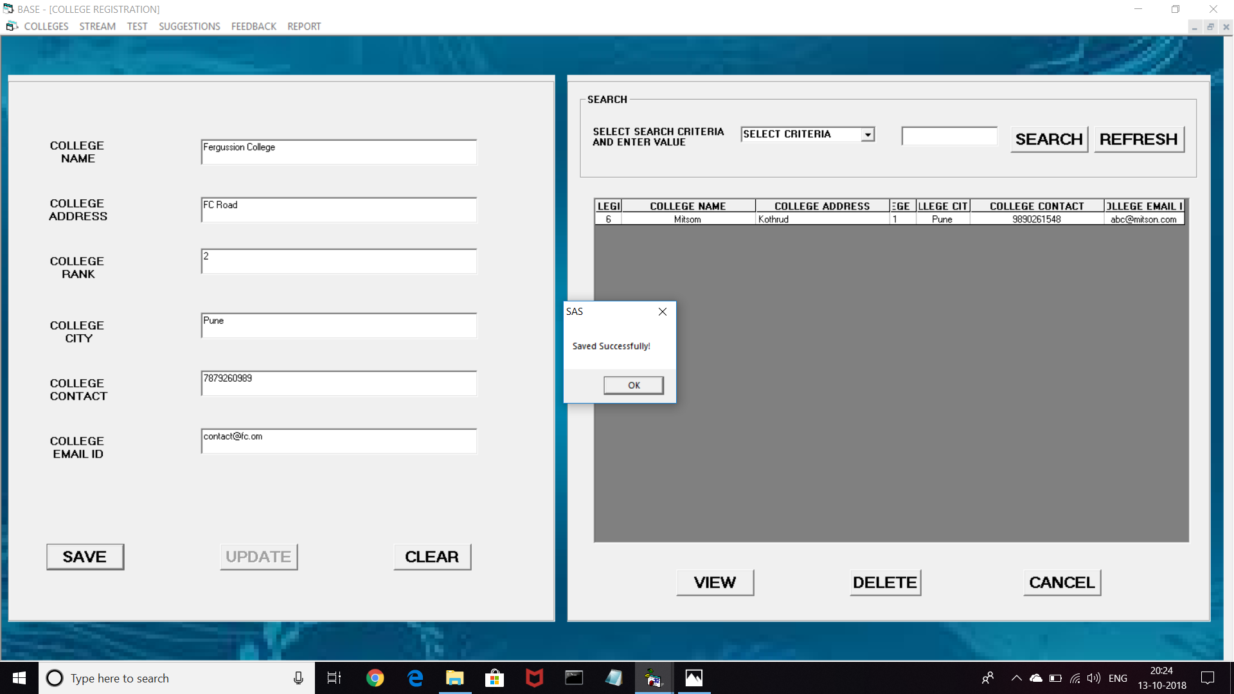

**STREAM REGISTRATION FORM**

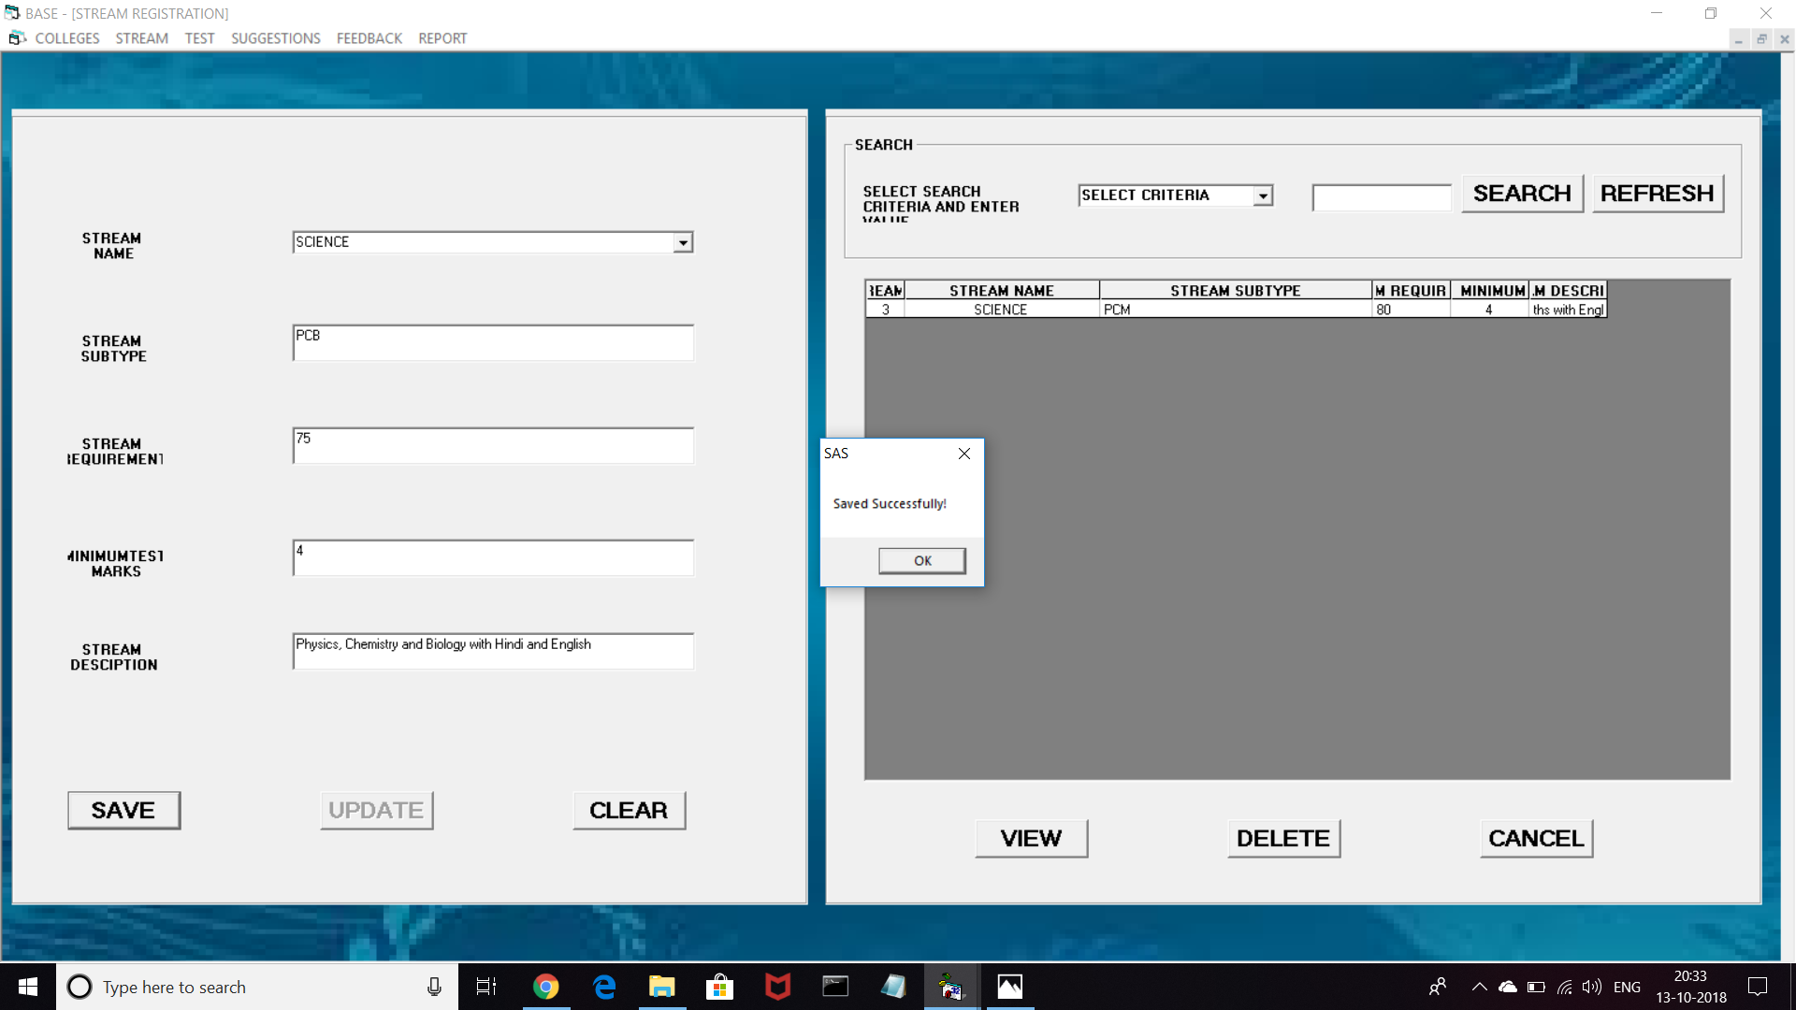

**COLLEGE STREAM REGISTRATION FORM**

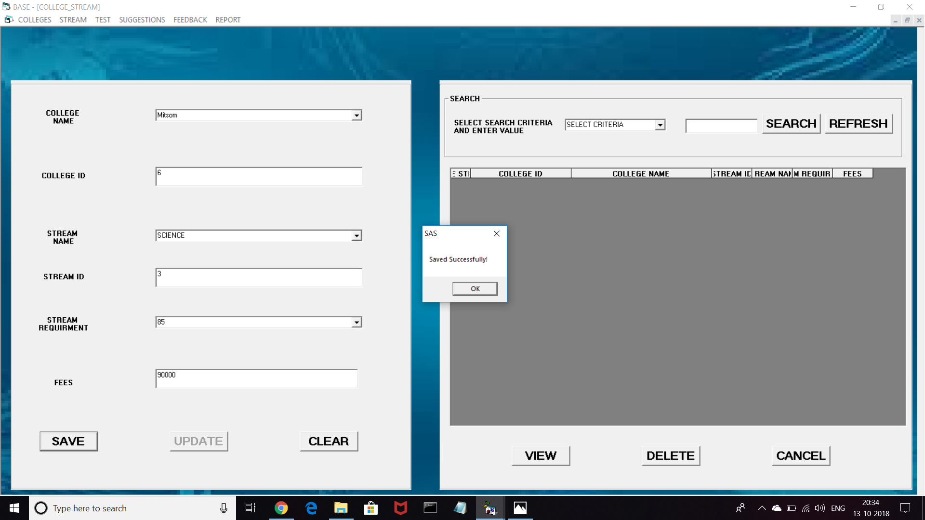

**QUESTION REGISTRATION FORM**

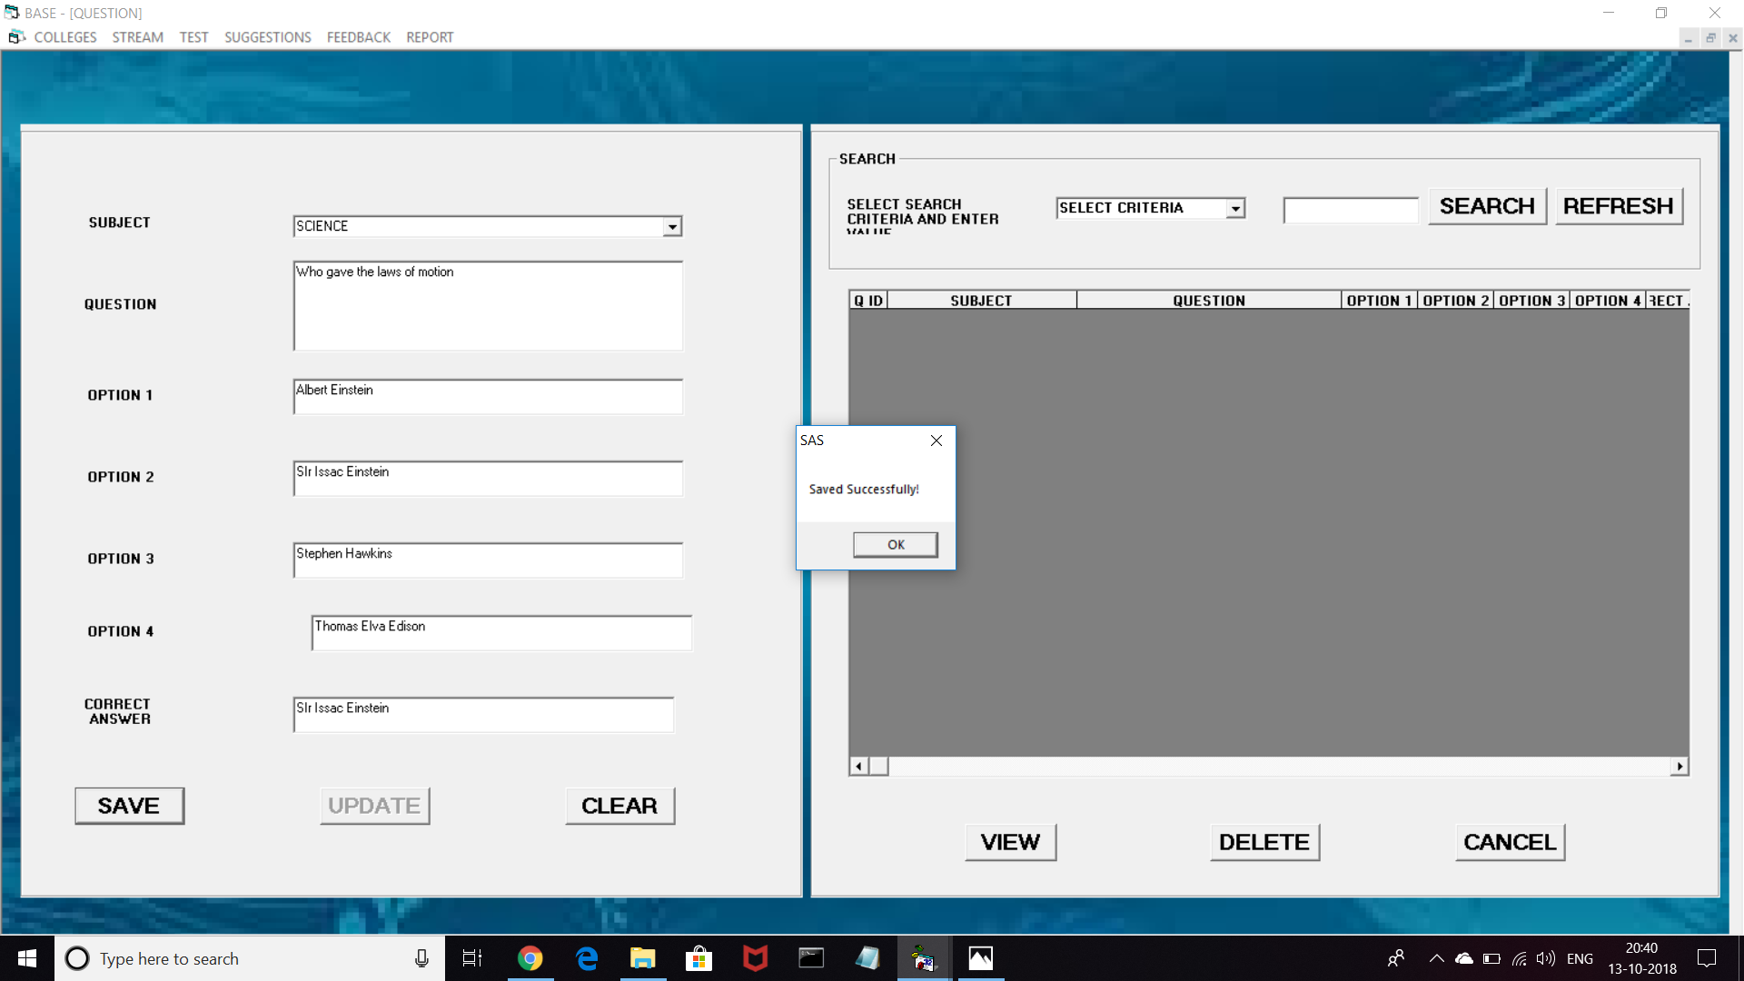

**APTITUDE TEST FORM**

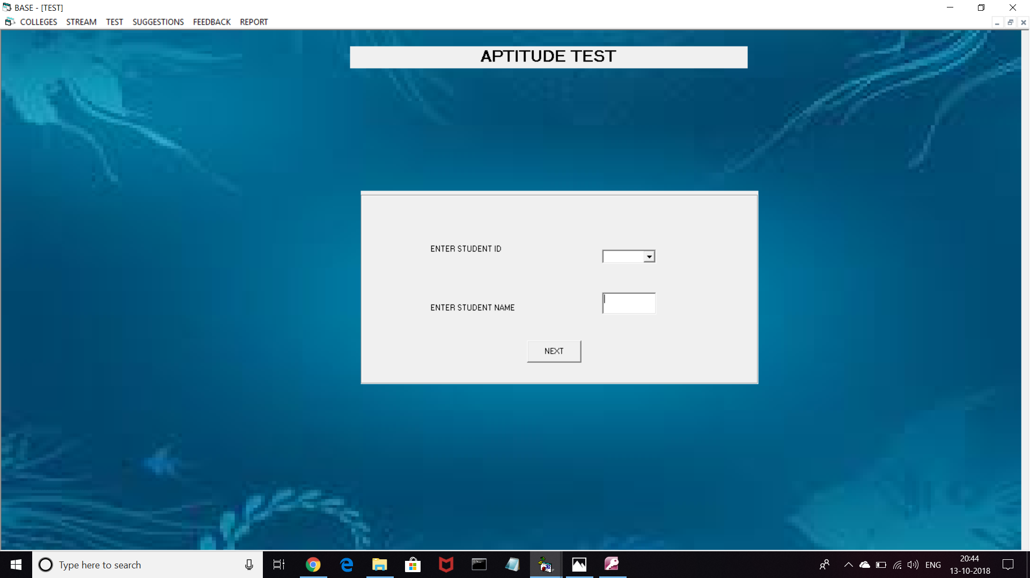

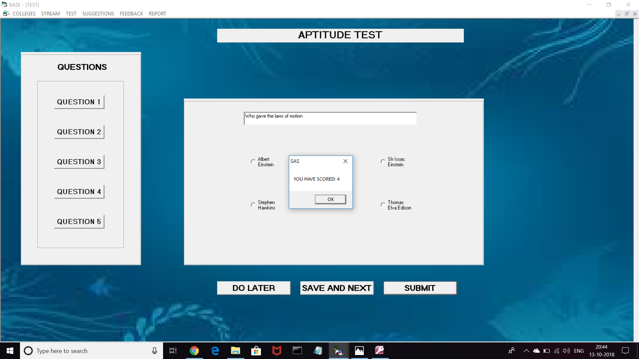

**SUGGESTIONS FORM**

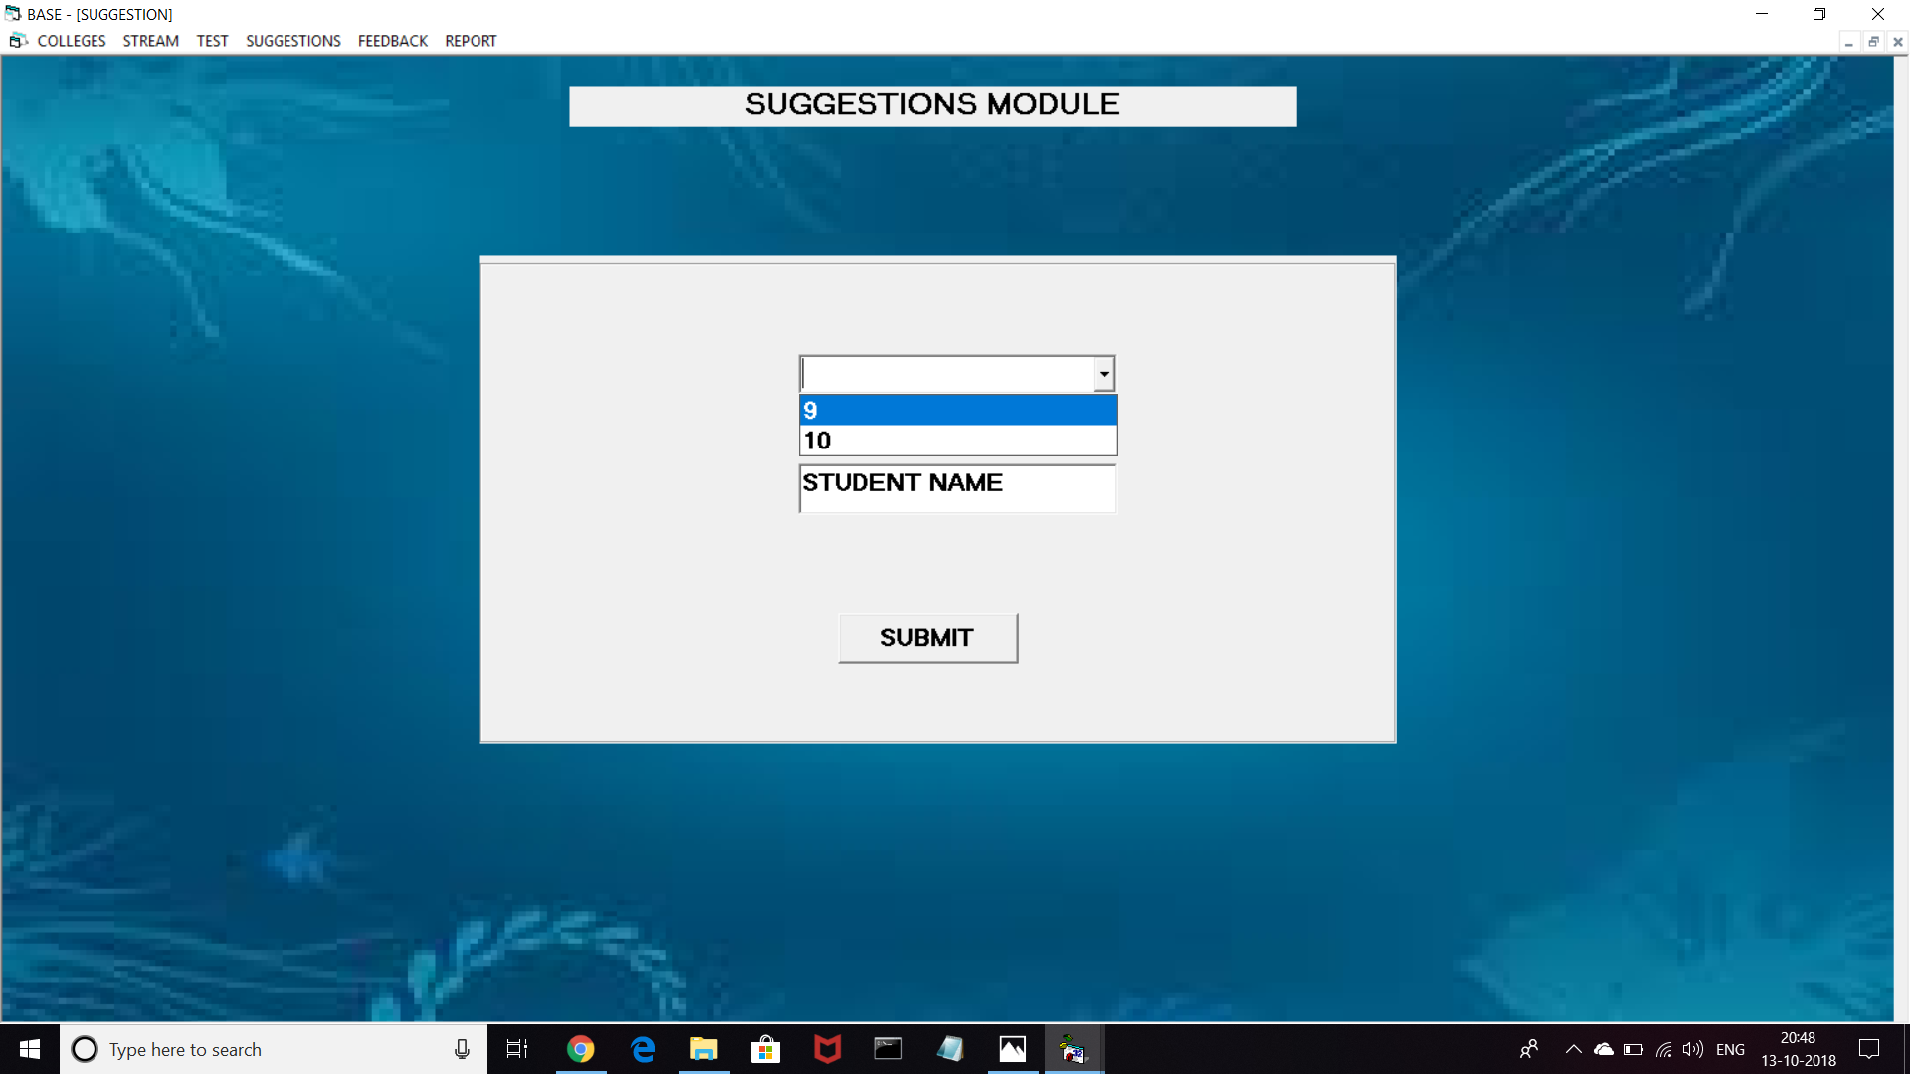

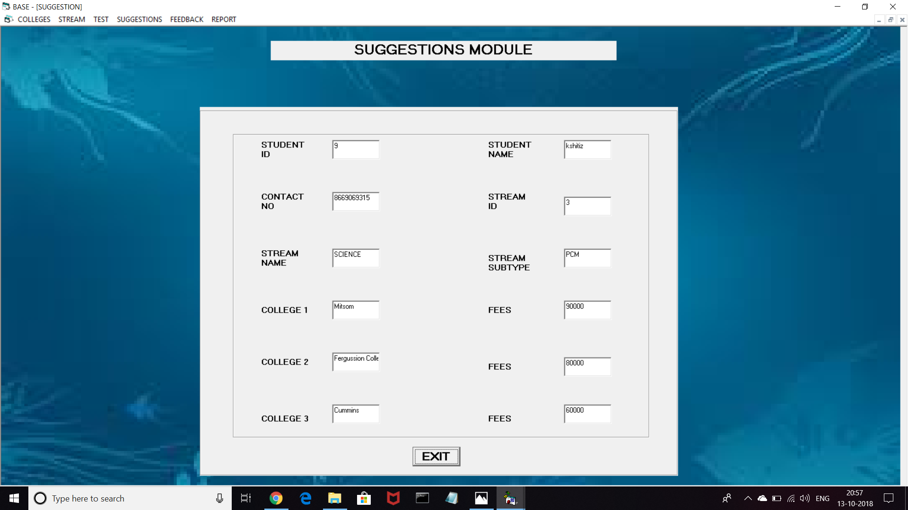

**FEEDBACK FORM**

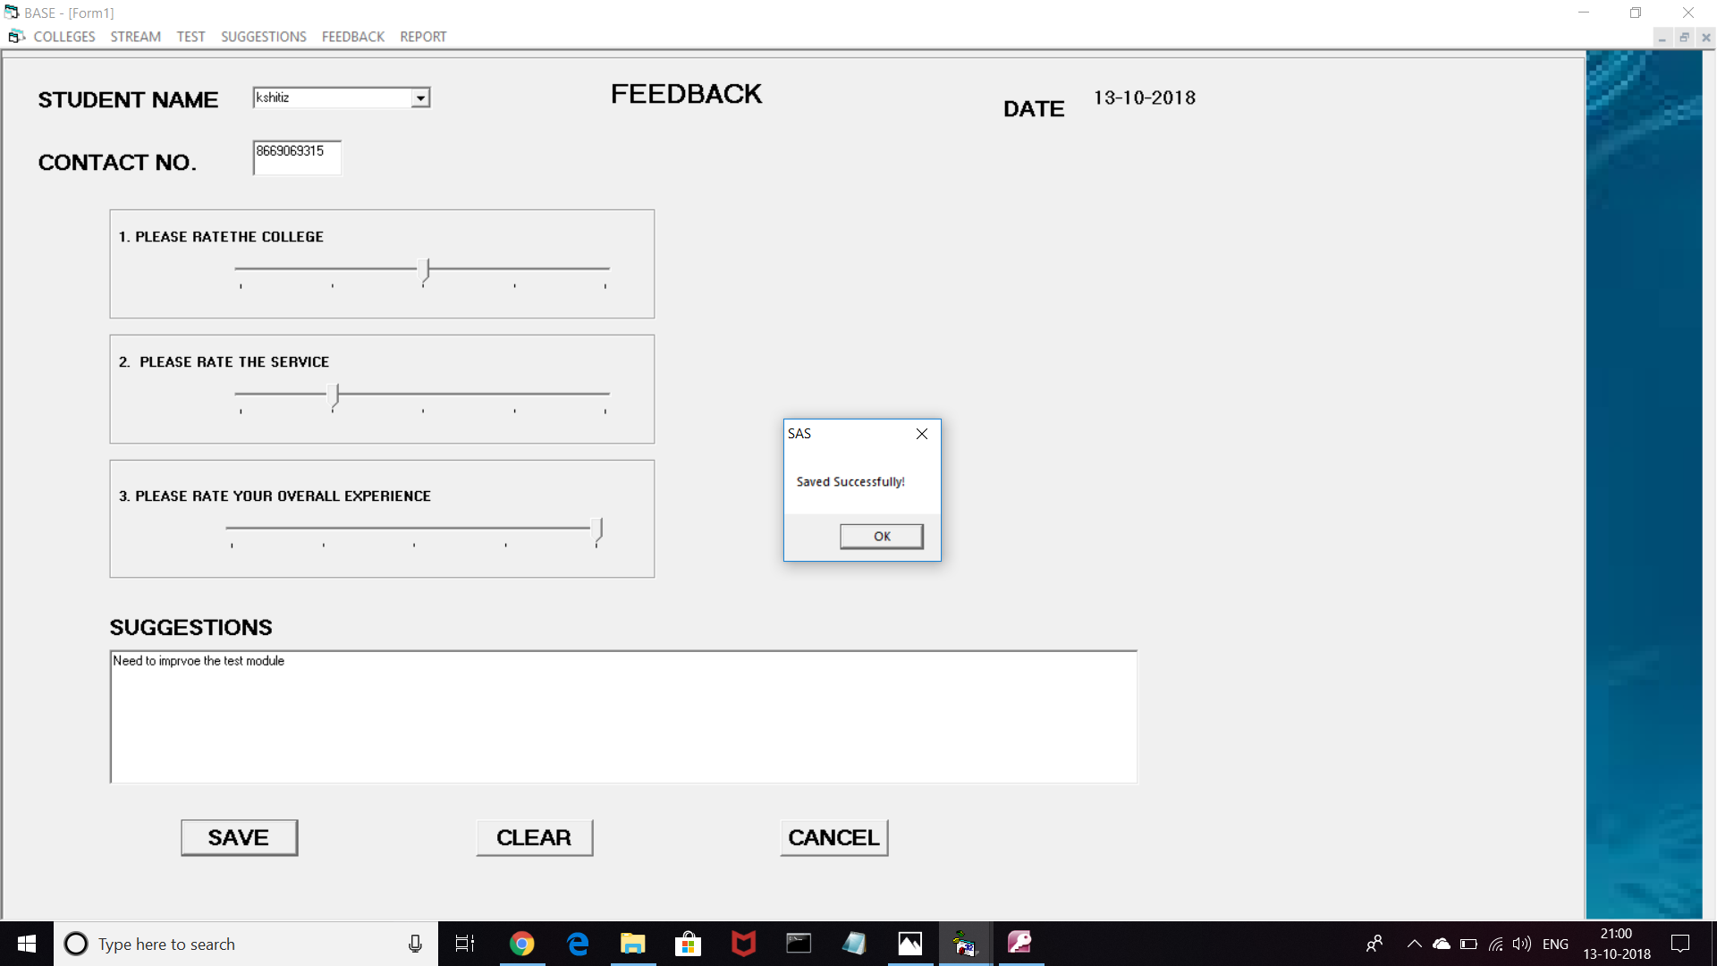

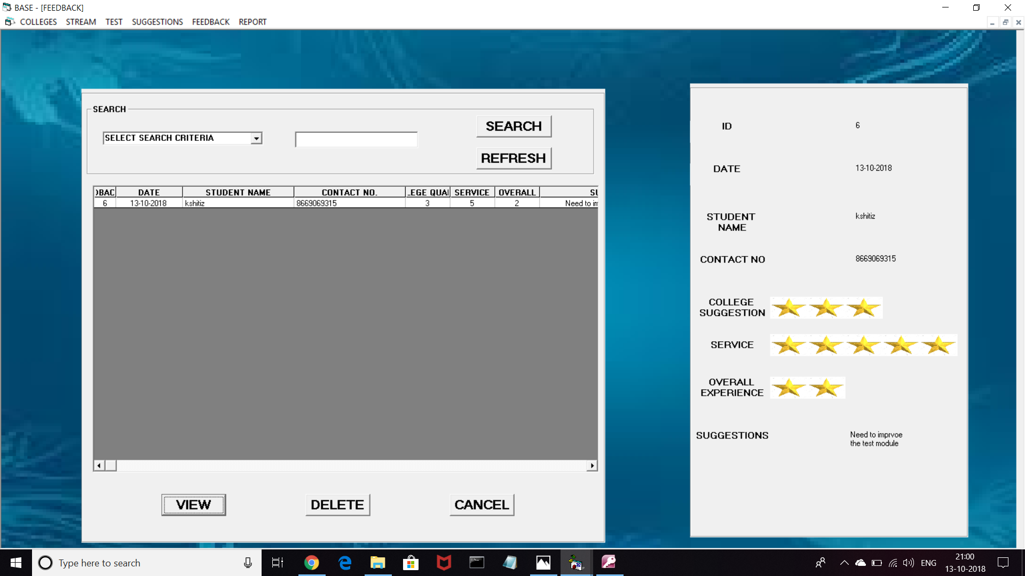

**STUDENT REPORT**

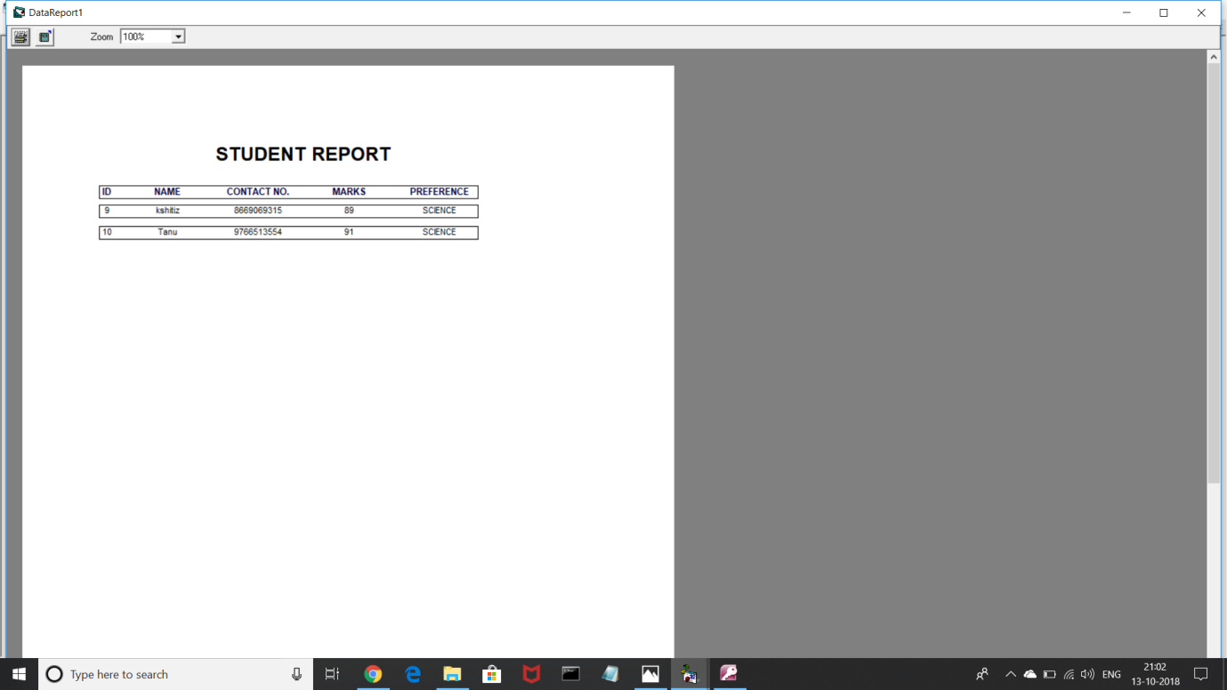

**TEST REPORT**

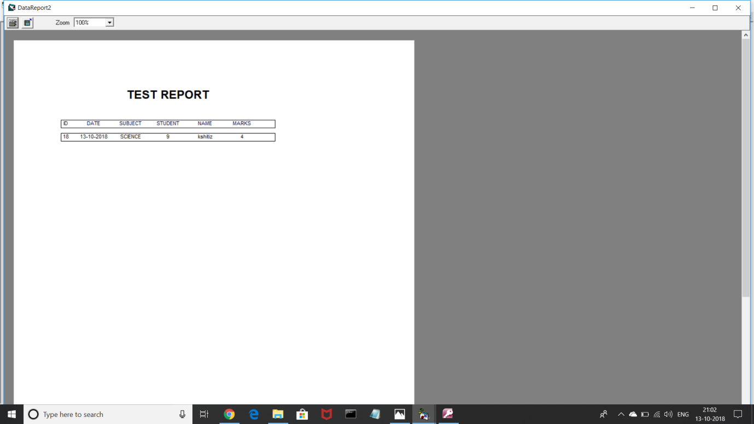

**ADVANTAGES AND LIMITATIONS**

* **Advantages:**

The system is very simple in design and to implement. The system requires very low system resources and will work in almost all configurations.

It has got following advantages:

* User friendly application.
* Secured database.
* Fast processing.
* Data can be updated easily.
* Database records can be maintained in computers.
* Any records can be retrieved when required.
* System reduces manual workload.
* Redundancy of data is avoided.
* Records can be searched and sorted easily.
* Less error prone and accuracy is maintained.
* Provides data reports.
* Has a direct link to the A page of Savitribai Phule Pune University.
* **Limitations:**

Every system has some limitations or drawbacks. Some of the limitations of National Service Scheme System are:

- It is a Stand Alone System.

- It can be used by a Single Person.

-As it is machine dependent, machine failure may result in data loss.

- Some manual data entry required.

**BIBLIOGRAPHY**

* **BOOKS REFERRED :**
* Learn VB in 72 Hours
* Complete Reference VB
* VB Tutorials
* **WEBSITES REFERRED :**
* [www.bigresource.com](http://www.bigresource.com)
* [www.vb.nettutorials.com](http://www.vb.nettutorials.com)
* [www.mitsomcollege.com](http://www.mitsomcollege.in)